**Checkpoint MongoDB**

Q1.Create a database called "contact"

Q.2.Create a collection called "contactlist"

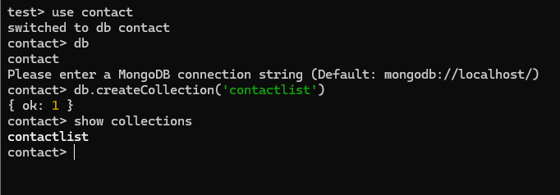

Q.3. Insert these documents in "contactlist" :

Last name: Ben, First name: Moris, Email: ben@gmail.com, age:26

Last name: Kefi, First name: Seif, Email: kefi@gmail.com, age:15

Last name: Emilie, First name: brouge, Email: emilie.b@gmail.com, age:40

Last name: Alex, First name: brown, age: 4

Last name: Denzel, First name: Washington, age:3

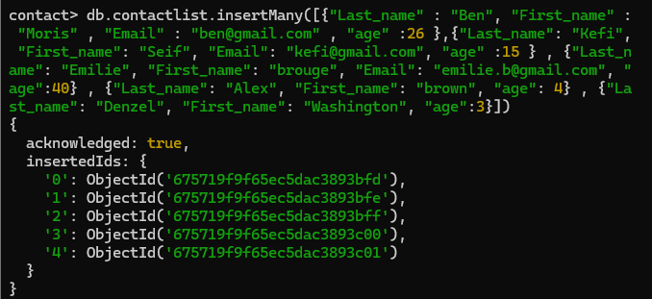

Q.4. Display all the information about only one person using his ID.

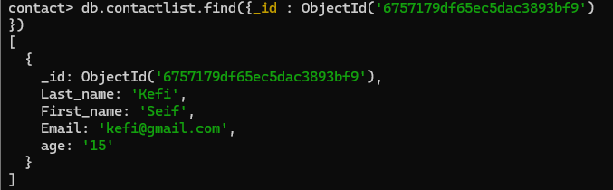

Q.5.Display all the contacts with an age >18.

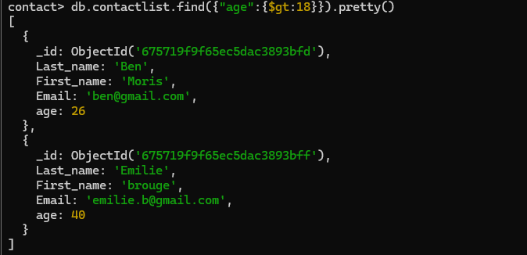

Q.6.Display all the contacts with an age>18 and name containing "en".

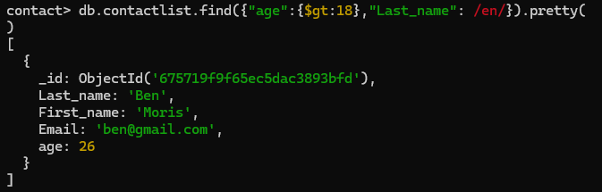

Q.7.Change the contact's first name from"Kefi Seif" to "Kefi Anis".

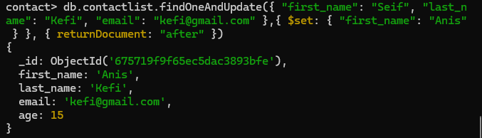

Q.8.Delete the contacts that are aged under <5.

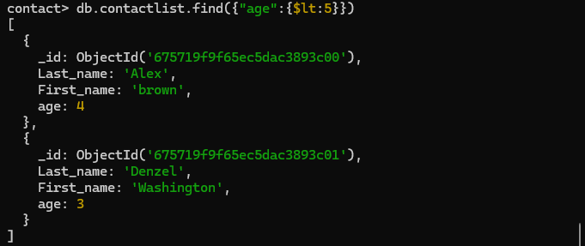

Q.9.Display all of the contacts list

